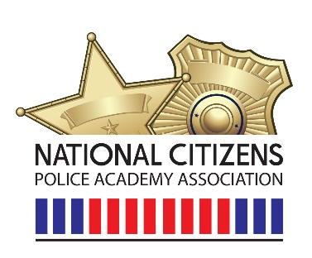

11/08/2023
Dear Valued Members,
Thank you for making our Virginia Beach Conference a success! While I’m glad that Zoom kept us together, It was great seeing everyone in person. I’m looking forward to continuing the relationships in 2024 and beyond.
A little about me, I am a patrolman with the Fishers Police Department in Fishers, IN. I was hired on in 2001 and joined our citizens academy program in 2002. I helped our alumni form in 2006 and have been their liaison ever since. I joined the National Citizens Police Academy in 2019 at the Memphis Conference as a Director. I have been blessed to have had the opportunity to be the Vice President and now President of the organization.
I look forward to working with the Board of Directors and continue building the organization. I believe our webpage can be a great source of information for our current membership and those looking to join. I will be contacting our members to help supplement the webpage with the variety of opportunities that encompass a citizens academy.
We have already started on a conference for 2025 and are excited to plan more great opportunities for members to grow the citizens academies in their organization. We have a passionate BOD and are excited for what lies ahead.

Sincerely,
James Alvis

