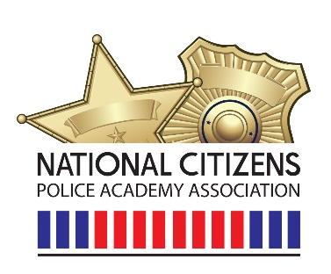

04/19/2024
Dear Valued Members,
Great news!! Our Board of Directors is growing and growing. We have two new Board of Directors this since our conference in September. Please join me in welcoming them:
Officer Grant Weil from Aurora Police Department Aurora, IL. Officer Weil has been with the Aurora Police Department since 2016 and with Indiana University Police Department for three years prior to APD. Officer Weil is the Coordinator for APD’s Citizens Police Academy, Bloodhound Handler, and helped establish the departments Spanish CPA.
Janice Lindley from Aurora Police Department Citizens Police Academy Alumni. Janice has been a member of CPAAA (Aurora, IL) since 2013 and on the Board of Directors since 2014. Serving as the 1st Communications Coordinator, along with being the 2nd Vice President and now back as the Communications Coordinator.

Lt. Jason Jones from Portland Police Department will be representing the NCPAA while attending the PLECET (Professionalizing Law Enforcement Community Engagement Training) conference in May. This is a great opportunity to increase awareness for our organization and our 2025 conference.
We will have a special opportunity to have Matt Peskin, the Executive Director of National Night Out, with us on June 12th, 2024 at 1:00pm EST on our Members Only page. Mr. Peskin will be discussing NNO and providing a Q&A session.
Great things going on and great things to come. Stay tuned and plugged in.
Sincerely,
James Alvis

