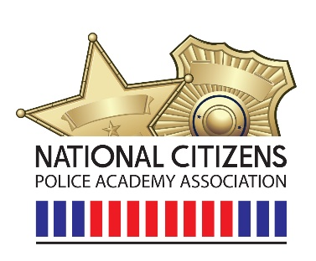

11/12/2025
Dear NCPAA Members and Friends,
What a great seminar by Dr. Jason Jones! There was a lot of great information for all of us to use. A big thank you to Dr. Jones for taking time out of a busy schedule to share his research with us.
With that said, please plan to join us with Dr. Jason Jones for Part 2 of the NCPAA Lunch & Learn Series: The Secret Sauce for Successful and Effective Citizen Police Academies. Building on the foundation from part 1 of the series, this session reveals key findings from Dr. Jones’s doctoral dissertation. Based on the themes from interviews with community leaders and law enforcement officials, this seminar examines how meaningful engagement can transform beliefs, inform community leader decision-making, and foster collaboration on public safety issues. Participants will gain insight into how program design, experiential learning, and authentic dialogue lay the foundation for relationship development, long-term impact, and return on investment. Learn how research-based strategies can transform your CPA into a powerful bridge between police and community and ensure that your academy fosters civic engagement that lasts well beyond graduation.
As stated previously, this seminar will be exclusive to NCPAA members. Please secure your membership prior to the February seminar. Any new memberships between now and the end of the year will only be charged the $50 membership fee and will be in good standing throughout 2026.
Stay Safe,
James Alvis
President of NCPA

